PUBLIC NOTICE
HUME CITY COUNCIL
NOTICE OF INTENTION TO IMPLEMENT TRUCK BANS ON KONAGADERRA ROAD, WILDWOOD ROAD, GELLIES ROAD AND BARDWELL DRIVE
Hume City Council acting under clause 9 of Schedule 11 to the Local Government Act 1989, gives notice under section 223 of the Act, that it proposes to implement truck bans on Konagaderra Road, Wildwood Road, Gellies Road and Bardwell Drive by the installation of truck ban signs.
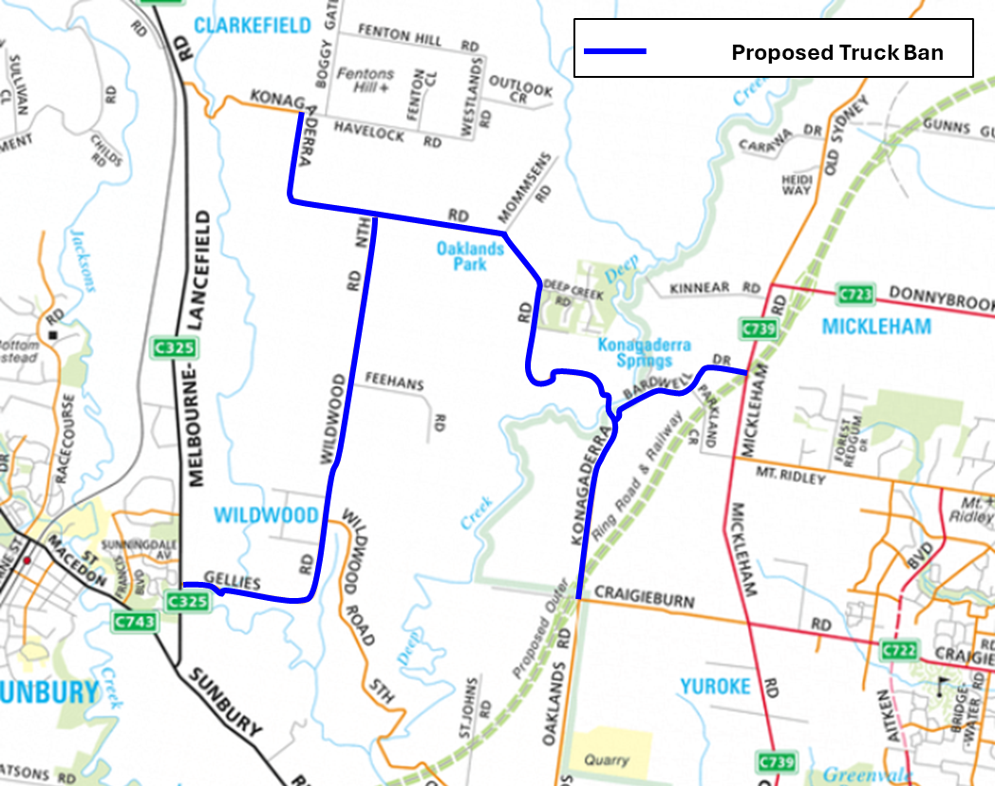
Souce: Melways Publishing Pty Ltd
Detours through the local road network implemented during the reconstruction of the Craigieburn Road / Mickleham Road intersection by Major Road Projects Victoria resulted in a significant increase in heavy vehicle traffic on the surrounding roads. Following the re-opening of the intersection, the elevated heavy vehicle volumes persist on Konagaderra Road, Wildwood Road, Gellies Road and Bardwell Drive.
Based on current truck volumes, it is apparent trucks are using these roads as through routes. Through trucks should be using the intended arterial road network where there is sufficient capacity.
Accordingly, to restrict through truck movements on these roads, it is proposed to install “No Trucks” signage as well as dimension related advisory signage at the designated entrance of each road.
Under the Road Rules, trucks are not permitted to drive past a ‘No Truck Sign’ unless they are servicing a property located directly on the route or if there is no other route a truck can use to reach its destination. Emergency vehicles are exempt from the No Truck Signs.
It is noted Truck Ban signs are a major traffic control device and will ultimately be subject to VicRoads approval. Should there be sufficient support for the truck ban, Council will table the proposal to VicRoads for review.
Council invites submissions on the proposal. Submissions must be submitted by no later than 5pm on 28 February 2025. Any person making a submission is entitled to request in the submission that the person wishes to appear in person, or to be represented by a person specified in the submission, at a meeting to be heard in support of that submission.
All submissions will be considered in accordance with section 223 of the Act.
Submissions should be addressed to the Chief Executive Officer, and can be emailed to contactus@hume.vic.gov.au, hand delivered to Council’s Broadmeadows Office at 1079 Pascoe Vale Road, Broadmeadows or posted to the following address:
Chief Executive Officer
Hume City Council
PO Box 119 Dallas VIC 3047
Any person requesting to appear in person or to be represented by a person specified in his or her submission is entitled to be heard before Council (or a Committee established by Council for this purpose) to be held (if required) Submitters will be contacted closer to the time on how/where the meeting will proceed. A person must clearly state in their submission whether they, or their representatives wish to speak at the meeting.
Further information regarding the proposal may be obtained from David Fricke, Manager Assets on (03) 9205 2200.

