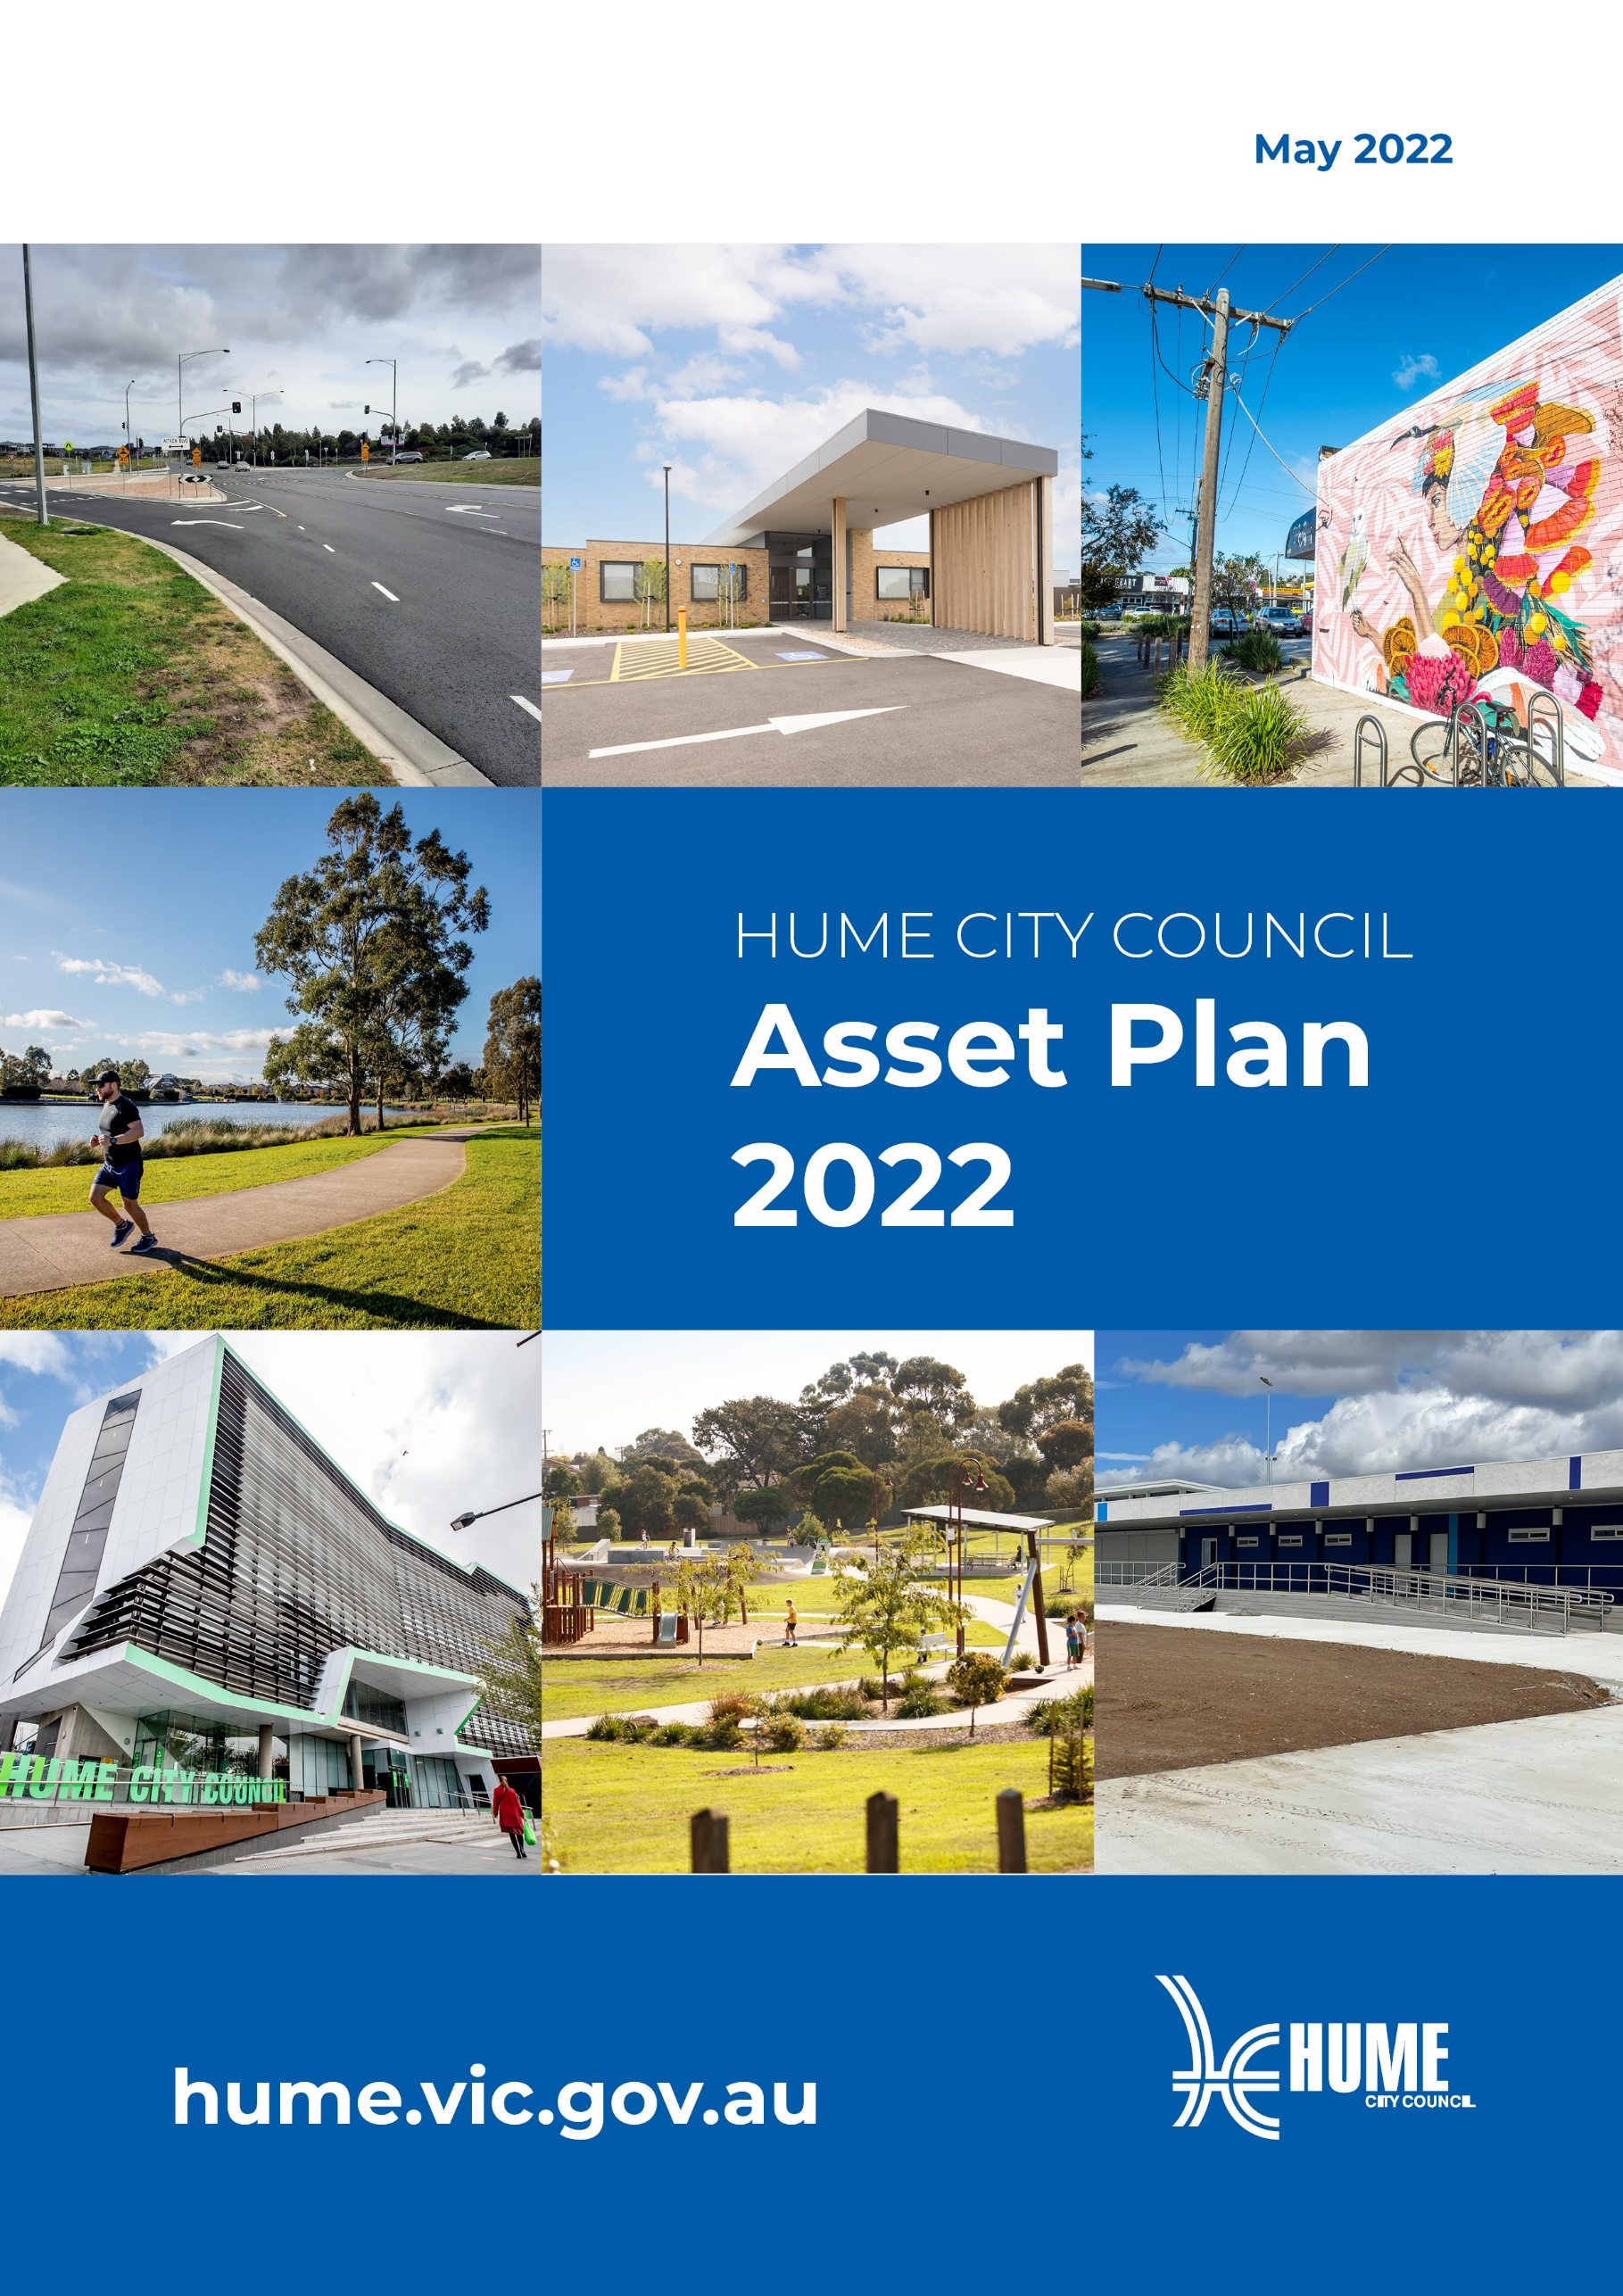
- Introduction
Council has a responsibility to the community to manage the assets it owns in a cost-effective manner. To achieve this, Council aims to manage its assets through their lifecycle from creation and acquisition to maintenance and operation, through to rehabilitation and disposal.
This Asset Plan sets out how Council intends to manage the assets it owns, to help achieve the objectives defined in the Council Plan 2021-2025. The Asset Plan integrates with Council’s Financial Plan, which identifies the resources available to Council over the next ten years. This will enable Council to manage its assets so that services can continue to support the needs of our community in the long-term. The Plan covers all infrastructure assets managed by Council excluding fleet, plant, equipment, trees and land.
The Asset Plan outlines:
- What assets Council has – It describes the main asset categories (eg. roads, buildings etc) and the total replacement cost of each category.
- The condition of our assets – Council regularly monitors the condition of assets and maintain records of condition, to help us budget for the maintenance, repair and renewal/replacement expenses that are required to keep the assets at an acceptable standard.
- The funding available in the long term to provide and look after our assets – The long-term cost of managing Council’s assets must be within the limited funding available as shown in Council’s Financial Plan.
- How much Council will spend on our assets – Over a ten-year period, the Asset Plan provides a breakdown of planned expenditure across three key categories:
  - Operating & maintenance
  - Renewal
  - Upgrade & new
- Challenges and opportunities – for each of main asset classes, the Plan provides an outline of some of the key issues that are anticipated over the next ten years.

- Planning Framework
The Local Government Act 2020, section 92, requires Council to develop an Asset Plan, to cover a period of at least the next ten financial years. The Asset Plan must include information about the maintenance, renewal, acquisition, expansion, upgrade, disposal and decommissioning in relation to each class of infrastructure asset under the control of the Council.
Our integrated Strategic Planning Framework describes how Hume City Council will work towards achieving the vision of our community.
This planning framework consists of several integrated long-, medium- and short-term plans that consider the priorities and resources needed to achieve the strategic objectives of Council. As demonstrated in Figure 1, each of these documents and plans outlines how they support and contribute to the delivery of the Community Vision and are underpinned by Council’s guiding principles of sustainability and social justice.

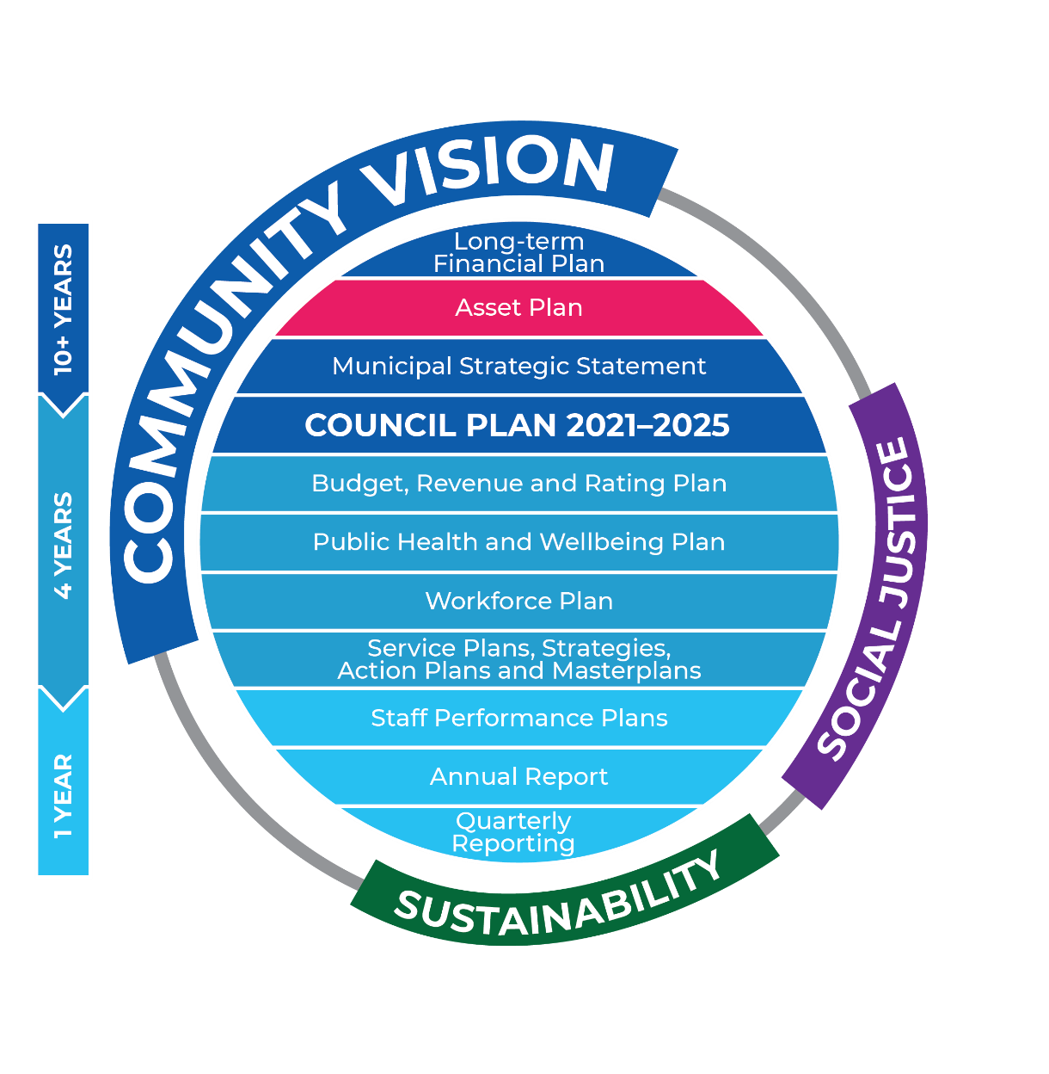
Figure 1 – Integrated Strategic Planning Framework
- Community Vision – Outlines the community’s aspirations for Hume City’s future. All of Council’s integrated strategic planning documents aim to support the delivery of this vision.
- Financial Plan – Outlines financial resources, decisions and assumptions required to support the delivery of the Council Plan and other strategic plans of the Council.
- Asset Plan – Outlines how Council will strategically manage our assets and infrastructure, including our obligations to maintain, renew and upgrade existing assets or expand or acquire new assets, or decommission or dispose of assets which are no longer required to support service delivery.
- Municipal Strategic Statement – Focusses on the physical, social, economic and environmental land-use planning and development strategies aimed at achieving the Community Vision. It provides the basis for planning application under the Hume Planning Scheme.

- Context
Hume City Council is located within metropolitan Melbourne. Council’s main administration office is located at 1079 Pascoe Vale Road, Broadmeadows 3047.
Spanning a total area of 504 square kilometres, Hume City is built around the established suburbs of Broadmeadows, Tullamarine and Gladstone Park in the south, the developing residential suburbs of Craigieburn, Greenvale, Mickleham, Kalkallo, and Roxburgh Park in the north-east and the Sunbury township in the north-west. Hume was home to more than 248,000 residents in 2021, and this population is forecast to grow to more than 372,000 by 2041.
The municipality is made up of vibrant and diverse communities, including new and established residential areas, major industrial and commercial precincts and vast expanses of rural areas and parkland. In comparison to metropolitan Melbourne, Hume City residents are relatively younger in age, and there is a higher proportion of ‘family households’. The Melbourne International Airport accounts for 10 per cent of the total area of Hume City.
Council owns infrastructure assets to support a range of services that are important to the community. The following services all depend on assets to support them, and the quality of Council’s assets has an impact on the quality of services experience by the community:
- Community services – children, families, youth, older people, health, disability support etc.
- Storm water management
- Arts and cultural services
- Emergency management
- Transport
- Waste management
- Leisure centres, sport and recreation
- Parks and open space
- Community facilities
- libraries
Some of the major issues and challenges Council is facing in relation to managing our assets are:
- Growth – Hume is one of the fastest growing municipalities in the State and this presents a range of challenges. Significant new infrastructure is constructed and handed over by developers each year. This needs to be monitored to ensure appropriate standards are achieved. Asset registers and forecasts of future maintenance and renewal costs need to be updated on a regular basis.
- Legislative changes – for example, provision and retrofit of existing assets to comply with new legislation
- Changes in population and demographics – for example, a shift in population age profile may result in changes to demand for facilities. This could result in the under-utilisation of facilities in parts of the municipality where a particular age demographic is decreasing as well as over-crowding or inability to meet demand where another demographic is increasing.
- Capacity and performance of assets – for example, an existing road cannot sustain the current traffic conditions, or a pavilion may be too small for the number of teams that now use it.
- Network Condition – for example, older drainage pipes and pits may not be functioning due to displacements or infiltration of tree roots, older footpaths become cracked and displaced, etc.
- Impacts of Climate Change – for example, lower overall rainfall contributes to loss of health of vegetation and makes it more difficult to maintain open space areas to the standards the community expects. Frequent storm events and heavier rainfall have resulted in immediate damage to assets such as wash-out of roads and the emergence of more potholes. The current design standard of drainage structures may not support frequent storm events.
To ensure appropriate infrastructure and services are in place for current and future generations, Hume City Council is required to adopt an Asset Plan to guide investment decisions.

- The Purpose of the Asset Plan
The purpose of the Asset Plan is to:
- Demonstrate the responsible management of assets (and services provided from assets).
- Compliance with regulatory requirements, and to
- Communicate the scale of infrastructure investment required to sustainably deliver affordable services for the community in the foreseeable future.
The Asset Plan provides a summary of the infrastructure assets, their performance and actions required to achieve the strategic objectives outlined in the “Asset Management Strategy 2020”.
The “Council Plan 2021-2025” was formed following extensive community engagement and identifies the community’s aspirations for the future of Hume City. Numerous workshops, surveys and events were conducted to engage with the community to establish their aspirations and vision for the municipality.
Council undertakes a range of community engagement activities that have been considered in the development of this Asset Plan.
As part of the development of the Community Vision and Financial Plan, between June and August 2021, Hume residents were provided with the opportunity to participate in an online budgeting simulation tool that enabled them to set Council’s budget based on key services provided by Council. The simulator tool required participants to balance the budget, and they were able to either maintain, increase or decrease the budget across a range of services by up to plus or minus five per cent based on existing funding.
The service domain of ‘Roads, traffic and transport networks’ received the largest increase (or decrease) for expenditure, with the overall response showing a desired increase of two per cent in spending for this service area. This would mean participants had to reduce expenditure in other areas to balance the budget.
Any trade-offs on performance, cost, and risk will be reviewed as part of future deliberative engagement with the community. Where risks are considered high, due assessment and control measures will be employed to ensure exposure is minimised as much as possible.
- The Approach
Hume City Council’s goal in managing infrastructure assets is to meet the required levels of service in the most cost-effective manner.
This Asset Plan supports Council’s Asset Management Policy and Strategy by incorporating a whole of lifecycle approach to forecast the renewals required to deliver the strategic objectives outlined in the “Council Plan 2021-2025”.
Future operating, maintenance, and capital renewal renewals are generally based on sustaining current service levels. Council’s Growth Infrastructure Plan and Development Contribution Plans provide details about the provision of infrastructure to meet the needs for Council services in growing suburbs.
The combined lifecycle costs are balanced with the funds made available in the “Financial Plan 2021/22 – 2030/31” with the aim of ensuring that services are provided at an affordable level.

- Assumptions
This is Council’s first iteration of the Asset Plan and it has been assumed that the funding for maintenance, operations and renewal is at an appropriate level in the first year of the Plan. This has been shown to be the case through successive State of Council Assets reports that demonstrate that the average condition of Council’s assets is not deteriorating, which indicates that maintenance and renewal needs are being met. This is also supported by more detailed modelling of renewal needs that has been done for each asset class, which has informed the budget process to ensure that renewal needs are being funded.
- The Assets and Services Council provides
Community values, stakeholder expectations and sustaining services at an affordable level are typically high on the agenda for ratepayers and members of the community.
Hume City Council provides a wide range of infrastructure assets that support services to the community.
COMPONENT | QUANTITY | UNIT | AVERAGE USEFUL LIFE (YEARS) | REPLACEMENT VALUE (Million)
Bridges | 170 | no | 50 - 100 | $ 96.5
Buildings | 278 | no | 20 - 50 | $ 462.6
Pipes and Culverts | 1912 | km | 100 | $ 490.4
Pits | 68,447 | no | 100 | $ 176.4
Head/End Walls | 681 | no | 100 | $ 1.8
Footpaths | 1,988 | km | 25 - 75 | $ 208.9
BMX, Skate Parks, and Exercise Stations | 48276 | m2 | 20 - 50 | $ 8.7
Flagpoles and water fountains | 87 | no | 30 - 100 | $ 2.0
Park shelters | 630 | no | 20 - 35 | $ 16.3
Fences & Walls | 254992 | m | 25 - 50 | $ 45.6
Park Furniture | 4965 | no | 15 - 25 | $ 14.0
Park Lighting | 1925 | no | 25 | $ 21.3
Playgrounds | 294 | no | 20 | $ 27.3
Sportsfields | 230 | ha | 25 - 30 | $ 59.7
Goals and scoreboards | 249 | no | 15 - 25 | $ 2.1
Irrigation Systems | 98 | no | 20 | $ 14.9
Roads | 1,391 | km | 12 -75 | $ 1,026.5
Kerb and Channel | 2,282 | km | 60 | $ 148.3
Carpark and Parking Bays | 437,726 | m2 | 12 -75 | $ 39.7
Road Islands and Traffic Management | 3516 | no | 10 - 75 | $ 40.5
TOTAL |  |  |  | $ 2,903.6
The Gross Replacement Cost of infrastructure assets is estimated at $2.9 billion, depreciating at approximately, 2.4 per cent each year as at 30 June 2021. It is important to note that depreciation reflects the annual consumption of existing assets on a straight-line basis. This is not a true reflection of the timing of renewal requirements. For example, an asset that is halfway through its life may still be in good condition and would not be expected to require renewal for some time.
Being a growing municipality, many of Hume City’s infrastructure assets are in the relatively early stages of their life. For example, drainage assets have an estimated life of 100 years, however the average age of drains in Hume is only around 23 years.
The valuations used in this Plan differ from the Gross Values reported in Council’s Financial Statement for the same time (30 June 2021).
For infrastructure assets, the variance is mainly due to the difference between valuation rates used between Financial Statement reporting and the Asset Management Plan. In the Financial Statements, the Australian Accounting standard requires the use of a 'Greenfield' valuation rate which estimates the cost to replace an asset assuming there are no existing underground services or adjacent buildings or other similar constraints that will adversely affect the cost of reconstructing or replacing the asset. However, in the Asset Plan, a 'Brownfield' rate has been applied which includes additional costs such as removal and disposal of existing assets, traffic management etc, but does not include any initial excavation costs such as earthworks.
The valuations for roads, footpaths and drainage were relatively consistent, with replacement costs differing from values in the Financial Statement by no more than 3 per cent. However, the variation was greater for buildings and open space assets, at 23 and 11 per cent respectively. This is because the values for buildings in the Financial Statement are measured at fair value, using the net revaluation method. The fair value represents a depreciated replacement cost which also considers the age and condition of the building at the time of the revaluation. The value used for open space assets in the Financial Statement is lower because it excludes assets below the valuation threshold of $5,000.

- Infrastructure Asset Performance
The infrastructure assets supporting these services are overall well maintained and in good condition, as shown in the following condition profile.

Figure 2 - State of Assets
Approximately 1 percent of the infrastructure assets are below desired performance levels (rated as being in poor condition). The estimated replacement costs of these assets are:
- Buildings ($0.17M)
- Drainage ($0.68M)
- Footpaths ($0.05M)
- Open Space ($2.03M)
- Roads ($13.75M)
Total ($16.7M)
- Future Demand
The demands for new and/or altered services can be created by impacts including:
- New residential development
- Change in land use
- Government policy and legislative changes
- Impacts of climate change
- Changes in community expectations
- Changes in population and demographics
- Changes in technologies

- Financial Projections

This section outlines the projected expenditure requirements for our infrastructure over the next 10 years.

For the purposes of the Asset Plan, our spending on our infrastructure is categorised as follow:
Expenditure Category | Description
Operational & Maintenance | Ongoing work required to keep an asset performing at the required levels of service.
Renewal | Returns the service potential or the life of the asset as it was originally.
New / Upgrade | Provision of new assets to provide a service.  An upgrade refers to enhancements or expansions to existing assets.

The financial projections shown within the section excludes the following:
- Furniture, plant, and equipment
- Land
- Salary capitalised in capital works projects

  - ROADS

The projected expenditure requirements associated with roads, carparks, kerb & channel, footpaths, and bridges over the next 10 years is shown here.

Activity Examples
Operational & Maintenance | Renewal | New / Upgrade
- Maintenance and repairs to roads such as patching potholes, crack sealing etc.  - Line marking  - Street sweeping  - Inspections of the road network. | - Resurfacing of existing roads.  - Road reconstruction of existing roads. | - Road widening.  - Duplication existing roads.  - Local Area Traffic Management treatments and enhancements.  - Road safety improvements

ROADS | 2021/22 | 2022/23 | 2023/24 | 2024/25 | 2025/26 | 2026/27 | 2027/28 | 2028/29 | 2029/30 | 2030/31
Operational & Maintenance | $5,747,599 | $6,011,701 | $6,298,459 | $6,610,233 | $6,947,355 | $7,289,512 | $7,641,231 | $8,007,246 | $8,387,190 | $8,777,194
Renewal | $17,334,662 | $18,976,148 | $21,648,780 | $23,853,656 | $21,193,949 | $21,953,983 | $22,741,283 | $23,610,899 | $24,514,021 | $25,452,448
New/Upgrade | $51,456,482 | $39,485,962 | $5,982,743 | $3,998,157 | $23,435,428 | $11,506,927 | $9,896,733 | $11,318,826 | $13,314,551 | $15,116,314

Over the next 10 years Council forecasts to spend around $478 million maintaining, renewing, and improving the Road network.
Challenges and Opportunities
Changing Population | Development impacts | Climate Adaption
- Population growth and new residential development results in higher traffic volumes  - Increased number of heavy vehicles on roads | - Development works can damage existing roads through heavy vehicle traffic, detours etc  - Utility renewals and upgrade to cater for growth areas affect the condition of existing roads | - Greater environmental sustainability requirements placed on the construction industry  - Incorporating recyclable materials for road surfaces.

Projects and Initiatives
- Road resurfacing and reconstruction of various roads
- Car park projects including new multi-deck car parks at Broadmeadows and Sunbury (these are the reason for the high new/upgrade figures in 2021/22 and 2022/23)
- Road duplication projects at Aitken Boulevard, James Mirams Drive, Silvester Parade and Elizabeth Drive.
- Annual kerb and channel renewal program
- Annual footpath renewal program
- Provision of new and safe footpath connectivity
- Local Area Traffic Management
- Blackspot treatments such as raised intersection platforms, new roundabout and provision of pedestrian signals

  - DRAINAGE
The projected expenditure requirements associated with pit, pipes, pipe culverts, water sensitive urban design treatments, and gross pollutant traps over the next 10 years is shown here.

Activity Examples
Operational & Maintenance | Renewal | New / Upgrade
- Pit cleaning  - Pipe cleansing and removal of debris, sediment, etc  - Removal of litter from Gross Pollutant Traps  - Programmed inspections | - Pipe and pit replacement.  - Pipe relining. | - Replacement of pits and pipes due to higher capacity requirements.  - Extension of drainage network.  - Installation of stormwater quality improvement treatments

Drainage | 2021/22 | 2022/23 | 2023/24 | 2024/25 | 2025/26 | 2026/27 | 2027/28 | 2028/29 | 2029/30 | 2030/31
Operational & Maintenance | $827,691 | $865,723 | $907,018 | $951,916 | $1,000,464 | $1,049,736 | $1,100,386 | $1,153,095 | $1,207,809 | $1,263,972
Renewal | $2,313,671 | $665,500 | $732,050 | $805,255 | $1,708,421 | $1,793,842 | $1,883,534 | $1,977,711 | $2,076,596 | $2,180,426
New/Upgrade | $1,938,121 | $2,560,000 | $2,521,000 | $372,000 | $383,000 | $394,000 | $406,000 | $418,000 | $438,900 | $460,845

Over the next 10 years Council forecasts to spend around $36 million maintaining, renewing, and improving the Drainage network.
Challenges and Opportunities
Changing Population | Ageing Assets | Climate Adaption
- New residential development may lead to more run-off thus creating pressure to the existing drainage network | - Increase in customer requests relating to drainage, consequently increasing reactive maintenance especially during an unexpected storm event  - More recurrent flooding events  - The ability to undertake timely renewal and upgrade of poor condition (or under capacity) stormwater assets | - Frequent and intense storm evens will pose an increased risk of flooding and reduce the reliability of capacity of the drainage network

Projects and Initiatives
- Drainage upgrade and rehabilitation projects
- Annual CCTV inspection of pipes
- Upgrade of Spavin Dam to ensure spillway meets current standards

  - BUILDINGS
The projected expenditure requirements associated with buildings and facilities over the next 10 years is shown here.

Activity Examples
Operational & Maintenance | Renewal | New / Upgrade
- Repairs to building components due to failure, vandalism, etc  - Provision of cleaning and security  - Safety and compliance inspections  - Painting  - Cleaning | - Replacing building components (e.g., carpet, heating and cooling systems, etc)  - Major structural repairs | - Building extensions and upgrades  - Building refurbishment  - Upgrade/extension of existing building  - Provision of new building to cater to increased or changing demand

Buildings | 2021/22 | 2022/23 | 2023/24 | 2024/25 | 2025/26 | 2026/27 | 2027/28 | 2028/29 | 2029/30 | 2030/31
Operational & Maintenance | $8,392,065 | $8,777,680 | $9,196,375 | $9,651,596 | $10,143,827 | $10,643,411 | $11,156,955 | $11,691,373 | $12,246,129 | $12,815,574
Renewal | $3,260,395 | $6,105,465 | $12,297,236 | $5,173,500 | $4,306,337 | $7,230,320 | $7,230,320 | $7,230,320 | $7,230,320 | $7,230,320
New/Upgrade | $35,992,527 | $41,175,720 | $18,222,634 | $16,648,898 | $15,270,946 | $15,290,642 | $10,527,136 | $7,538,465 | $2,447,884 | $5,863,153

Over the next 10 years Council forecasts to spend around $341 million maintaining, renewing, and improving its Buildings and facilities.
Challenges and Opportunities
Changing Population | Climate Adaption | Technology
- Population growth may lead to increased demand or changes for a demand for council services  - Facilities will need to be adaptable to meet the changing demographic | - More frequent and intense weather events will increase building damage  - Incorporating solar panels to buildings  - Incorporating smart, energy efficient components to buildings | - Advances in technology provide opportunity to improve efficiencies  - Demand for online and other innovative service delivery approaches can be expected  - Increased demand for technology-enabled buildings

Projects and Initiatives
- Construction of new pavilions, community centres, etc
- Refurbishment and Upgrade of existing buildings
- Annual service and compliance inspection programs

  - OPEN SPACE
The projected expenditure requirements associated with reserves, sports fields, playgrounds, park furniture, lighting, fences, walls, and irrigation systems is shown here.

Activity Examples
Operational & Maintenance | Renewal | New / Upgrade
- Playground inspection  - Mowing, vegetation/weed control  - Litter collection | - Playground replacement  - Park furniture replacement  - Turf renewal and court surface renewal | - Upgrading open space assets  - Development of new parks/reserves  - New sports facilities

Open Space | 2021/22 | 2022/23 | 2023/24 | 2024/25 | 2025/26 | 2026/27 | 2027/28 | 2028/29 | 2029/30 | 2030/31
Operational & Maintenance | $30,077,761 | $31,459,834 | $32,960,468 | $34,592,011 | $36,356,204 | $38,146,747 | $39,987,327 | $41,902,720 | $43,891,004 | $45,931,936
Renewal | $4,041,887 | $4,362,158 | $4,932,652 | $4,064,798 | $3,237,443 | $3,350,754 | $3,468,030 | $3,589,411 | $3,715,041 | $3,845,067
New/Upgrade | $34,681,844 | $31,513,284 | $33,343,573 | $19,513,202 | $28,135,194 | $11,232,341 | $17,747,779 | $7,979,563 | $8,219,314 | $20,207,896

Over the next 10 years Council forecasts to spend around $626 million maintaining, renewing, and improving its Open Space.
Challenges and Opportunities
Changing Population | Climate Adaption | Participation Patterns
- Population growth may lead to increased demand for a specific recreational activity or landscape setting.  - New open spaces in growth areas and to suit changing demographics | - Drought resistant turf renewal  - Incorporating smart, energy efficient assets to reserves  - Viability of providing services such as irrigation | - Changes in sporting trends may change demand for traditional recreational activities such as ovals  - Increased demand for skate parks, exercise stations, dog parks etc

Projects and Initiatives
- Masterplans
- Playground renewal
- Turf renewal
- Annual renewals of playrounds, warm season grass, goal posts, sports infrastructure and sports surfaces

  - TOTAL EXPENDITURE

The following figure shows the planned expenditure across all infrastructure assets included in this Asset Plan over the next 10 years.

This is further summarised in the table below, which shows the total planned expenditure related to renewal, new, upgrades, and operational and maintenance activities over the next 10 years.

Asset Class | Operational & Maintenance | Renewal | New/Upgrade
Roads | $71,717,721 | $221,279,829 | $185,512,121
Drainage | $10,327,810 | $16,137,006 | $9,891,866
Buildings | $104,714,985 | $67,294,533 | $168,978,005
Open Space | $375,306,013 | $38,607,242 | $212,573,990
Total | $562,066,529 | $343,318,610 | $576,955,982

There is an estimated total of $1.48 billion of asset expenditure planned in the next 10 years. Of this:
- Around 38 per cent ($562 million) relates to ongoing maintenance activities to ensure that assets are safe and functional.
- Around 23 per cent ($343 million) relates to renewal expenditure for replacement of assets that are reaching the end of their lives.
- Around 39 per cent ($577 million) relates to expenditure to meet growth or additional future demand.
The Next Steps
The medium to long-term outlook suggests that priorities should remain focused on ensuring the operation, maintenance, and replacement of existing assets at sustainable levels whilst monitoring and responding to demand and growth challenges as they occur.
The actions resulting from this Asset Plan are:
- To review asset useful lives and condition rating and align these with up-to-date performance data and knowledge with the financial reports.
- To continuously plan and review the services delivered to the community and ensure that the asset base supports these services in the most efficient way.
- Ongoing review of lifecycle cost analysis.
- Scoping all whole of lifecycle costs associated with new projects. This ensures that all ongoing costs and services associated with new or upgraded assets have been accounted for.



