

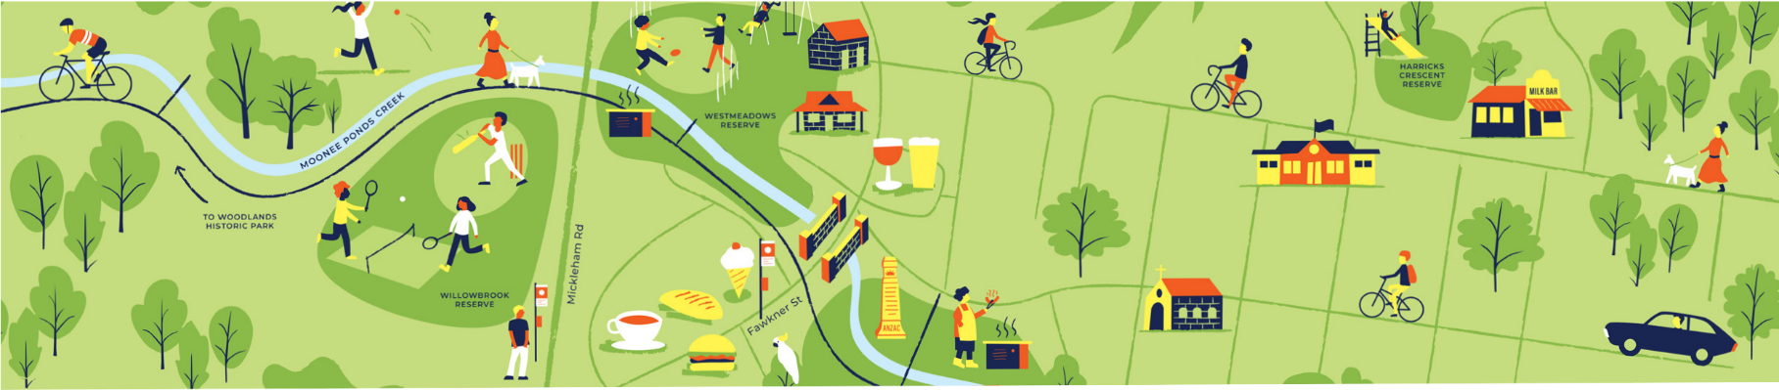
Westmeadows Public Space Plan

BUILDING A BETTER HUME
The next phase of design for the Westmeadows Public Space Plan has commenced and it will incorporate your feedback.
A summary of your feedback
The Fawkner Street Village shops have been identified as the top priority for renewal in the Westmeadows Public Space Plan site area.

The community is most satisfied with local businesses and natural features.

The most important aspects for improvement in Westmeadows are neighbourhood safety and natural features.

Traditional bluestone has been identified as a key material for use in Westmeadows.

Native planting is supported as the most popular planting option in the site area.

Most respondents live locally and walk to the Westmeadows Public Space Plan site area.

Thank you for your feedback
2900 postcards were posted to local residents, businesses and other properties.

The participate page was open from June 6 - July 4 and received 753 visits.
182 visitors to the page became informed by clicking on or downloading a document.
294 of visitors to the page provided feedback via the online survey.
There will be further community engagement opportunities in 2023. These include site specific feedback opportunities and opportunities to comment on the Westmeadows Public Space Plan.
Visit participate.hume.vic.gov.au to keep informed about future work in Westmeadows.

